Chapter 17, Solution 9.

Determine the Fourier coefficients a_{n} and b_{n} of the first three harmonic terms of the rectified cosine wave in Fig. 17.52.

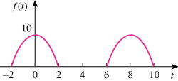

Figure 17.52
For Prob. 17.9.

Solution

f(t) is an even function, b_{n}=0.
For n = 1,
For n>1,

Thus,

